 | COSHH Risk Assessment No: 51 |  |  |  |  |  |  |  |  |  | 
Department: Hospice @ Home |  |  |  |  |  |  |  | Premises:  Various
Describe the activity or work process.  (Include how long and how often this is carried out and the quantity of substance used) |  |  | Sanitising hands with gel sanitiser
Location of process being carried out? |  |  | As required
Identify the persons at risk: |  |  |  | Employees  x  (including trainees) |  |  |  |  | Contractors |  |  | Public  x  (including students)
Name the substance involved in the process and its manufacturer.  (A copy of a current safety data sheet for this substance should be attached to this assessment) |  |  |  | Cutan Complete Hand Gel Sanitiser
Classification (state the category of danger)


Toxic
Extremely Flammable

Irritant

Very Toxic
x

Sensitising
x
Highly Flammable

Biological
Flammable


Corrosive

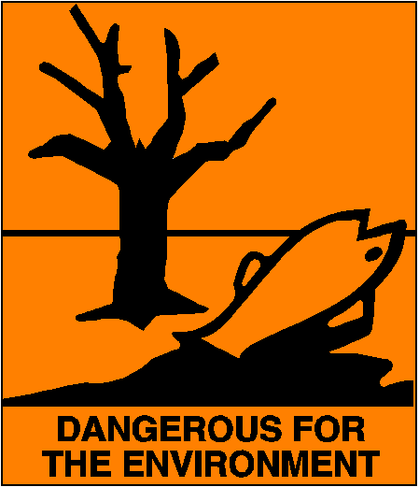
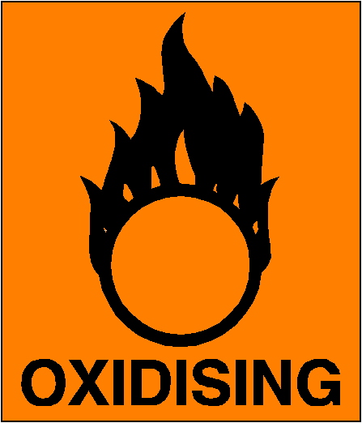

Environmental
Oxidising
Harmful

Hazard Type
x
x

Gas Vapour Mist Fume Dust Liquid Solid Other (State)
Route of Exposure
x

x

Inhalation Skin Eyes Ingestion Other (State)
Workplace Exposure Limits (WELs) please indicate n/a where not applicable
Long-term exposure level (8hrTWA):  Ethanol 100ppm 1920mg/m3  Glycerine10mg/m3 mist |  |  |  |  |  |  | Short-term exposure level (15 mins):
State the Risks to Health from Identified Hazards
Ingestion-may cause nausea, headache, dizziness and intoxication.
Eye contact-moderately irritating

Control Measures: (for example extraction, ventilation, training, supervision). Include special measures for vulnerable groups, such as disabled people and pregnant workers. Take account of those substances that are produced from activities undertaken by another employer’s employees.
Wear EEuropean Standard EN166 compliant eye and face protection when there is a risk of product splashing into eyes.

Is health surveillance or monitoring required?

x
Yes No
Personal Protective Equipment (state type and standard)
x  Dust mask |  |  |  |  |  | Visor
x  Respirator |  |  |  |  |  | Goggles
Gloves |  |  |  |  |  | Overalls
Footwear |  |  |  |  |  | Other
First Aid Measures
Get medical attention if any discomfort continues
Inhalation-Move affected person to fresh air and keep warm and at rest in a position comfortable for
breathing

Ingestion-DO NOT induce vomiting. Get medical attention immediately. Never give anything by mouth to
an unconscious person.

Skin contact-Not relevant.

Eye Contact-Remove any contact lenses and open eyelids wide apart. Continue to rinse for at least 15
minutes. Get medical attention promptly if symptoms occur after washing.

Storage
Disposal of Substances & Contaminated Containers
Hazardous Waste Skip Return to Depot Return to Supplier Other

(If Other Please State):
Is exposure adequately controlled? |  |  |  |  | Yes No
Risk Rating Following Control Measures
High Medium Low

Assessed by: Date: Review Date:

