

**Reflective Practice Template**

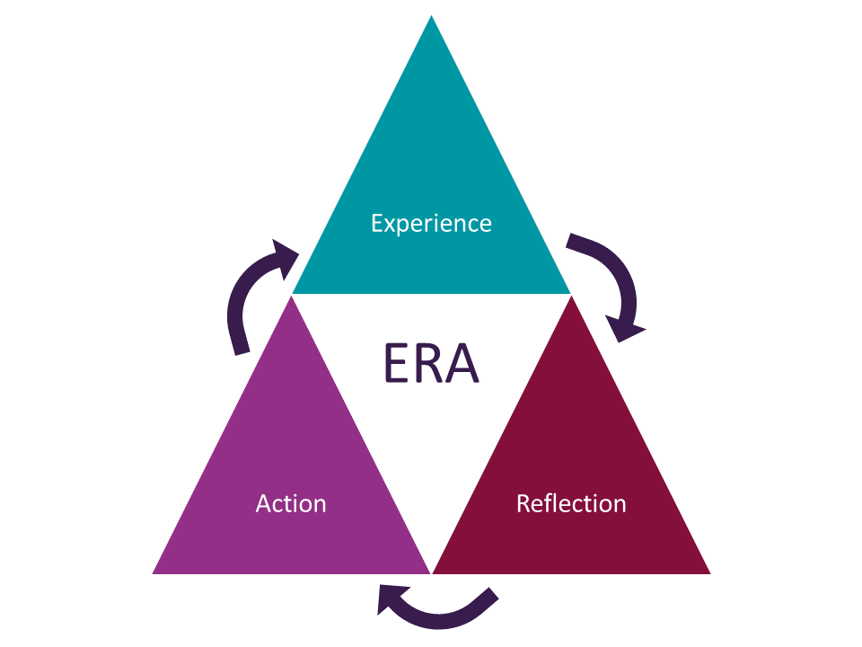

Considering the above model of reflection please use this template as a framework to support you with your reflections. The bullet points are there just as a guide and are optional to consider/use. Your reflections are your personal record of your engagement with reflective practice and remain confidential to you.

|  |  |
| --- | --- |
| **Name:** |  |
| **Date of Reflection** |  |
| **Method of reflection i.e. Written Reflection**  **One to one session**  **Group session** |  |
| **Title of reflective session** |  |
| **Description of the experience (E)**   * What was the event? * What happened versus what should have happened (outcomes)? * What was important? * Who was involved? Who wasn’t involved? (roles not names) * What are you proud of? | |
|  | |
| **Reflecting on the experience (R)**   * Why did it happen? Possible causes (e.g. communication, processes, resources), * What worked well, what could have improved? * Who (role/expertise) should have been involved? * What could be done differently? Assess options, need/possibilities for change, development /learning needs. * Is this something to share and celebrate? | |
|  | |
| **What actions do I need to take? (A)**   * Integrate/share innovative ideas? * Make a change? * Make contact with? * Identify additional support? * Any learning needs? | |
|  | |

**And finally…………**

**R**emember - Look back, review, ensure intense experiences are reviewed 'cold.’

**E**xperience - What happened? What was important?

**F**ocus - Who, what, where, etc. Roles, responsibilities, etc.

**L**earn - Question: why, reasons, perspectives, feelings?

**E**valuate - Causes, outcomes, strengths, weaknesses, feelings.

**C**onsider - Assess options, need/possibilities for change? Development needs? 'What if?'

**T**rial - Integrate new ideas, experiment, take action, make change.

Lawrence-Wilkes 'REFLECT' model of Reflective Practice